1. Write a program to reverse a word using loop? (Not to use inbuilt functions)

import java.util.Scanner;

class ReverseStringForloop

{

public static void main(String args[])

{

String str;

char ch;

System.out.println("Enter a String as you wish: ");

Scanner scan=new Scanner(System.in);

str =scan.nextLine();

System.out.println("Reserve of given String "+str+" is : ");

for(int j=str.length(); j>0; j--)

{

System.out.print(str.charAt(j-1))

}

}

}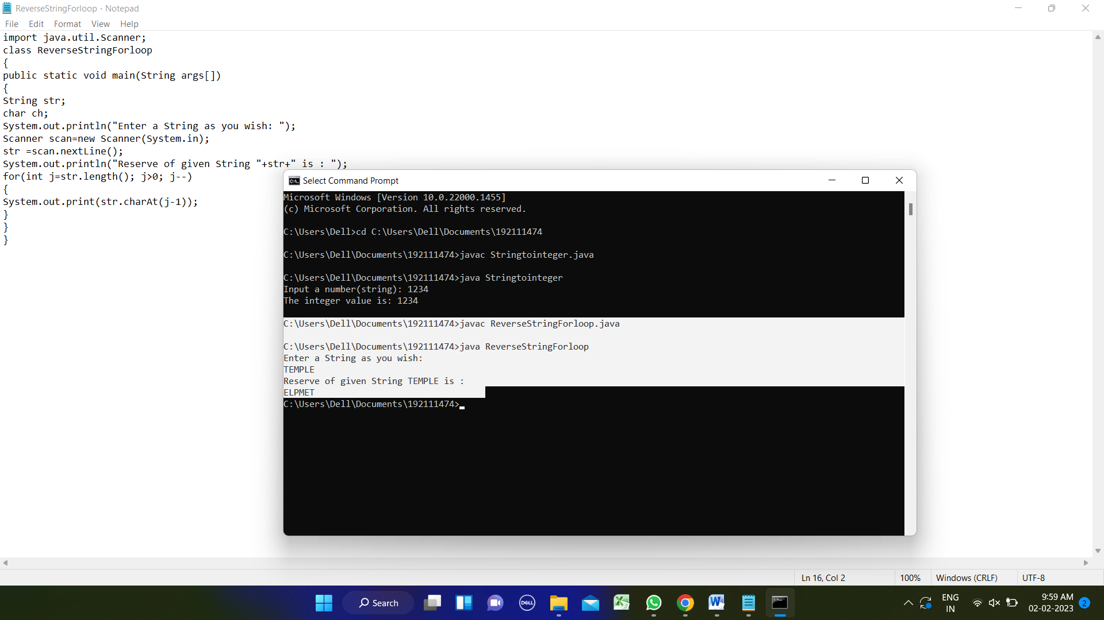

1. Write a program to convent the given string to integer?

import java.util.*;

public class Stringtointeger

{

public static void main(String[] args)

{

Scanner in = new Scanner(System.in);

System.out.print("Input a number(string): ");

String str1 = in.nextLine();

int result = Integer.parseInt(str1);

System.out.printf("The integer value is: %d",result);

System.out.printf("\n");

}

}

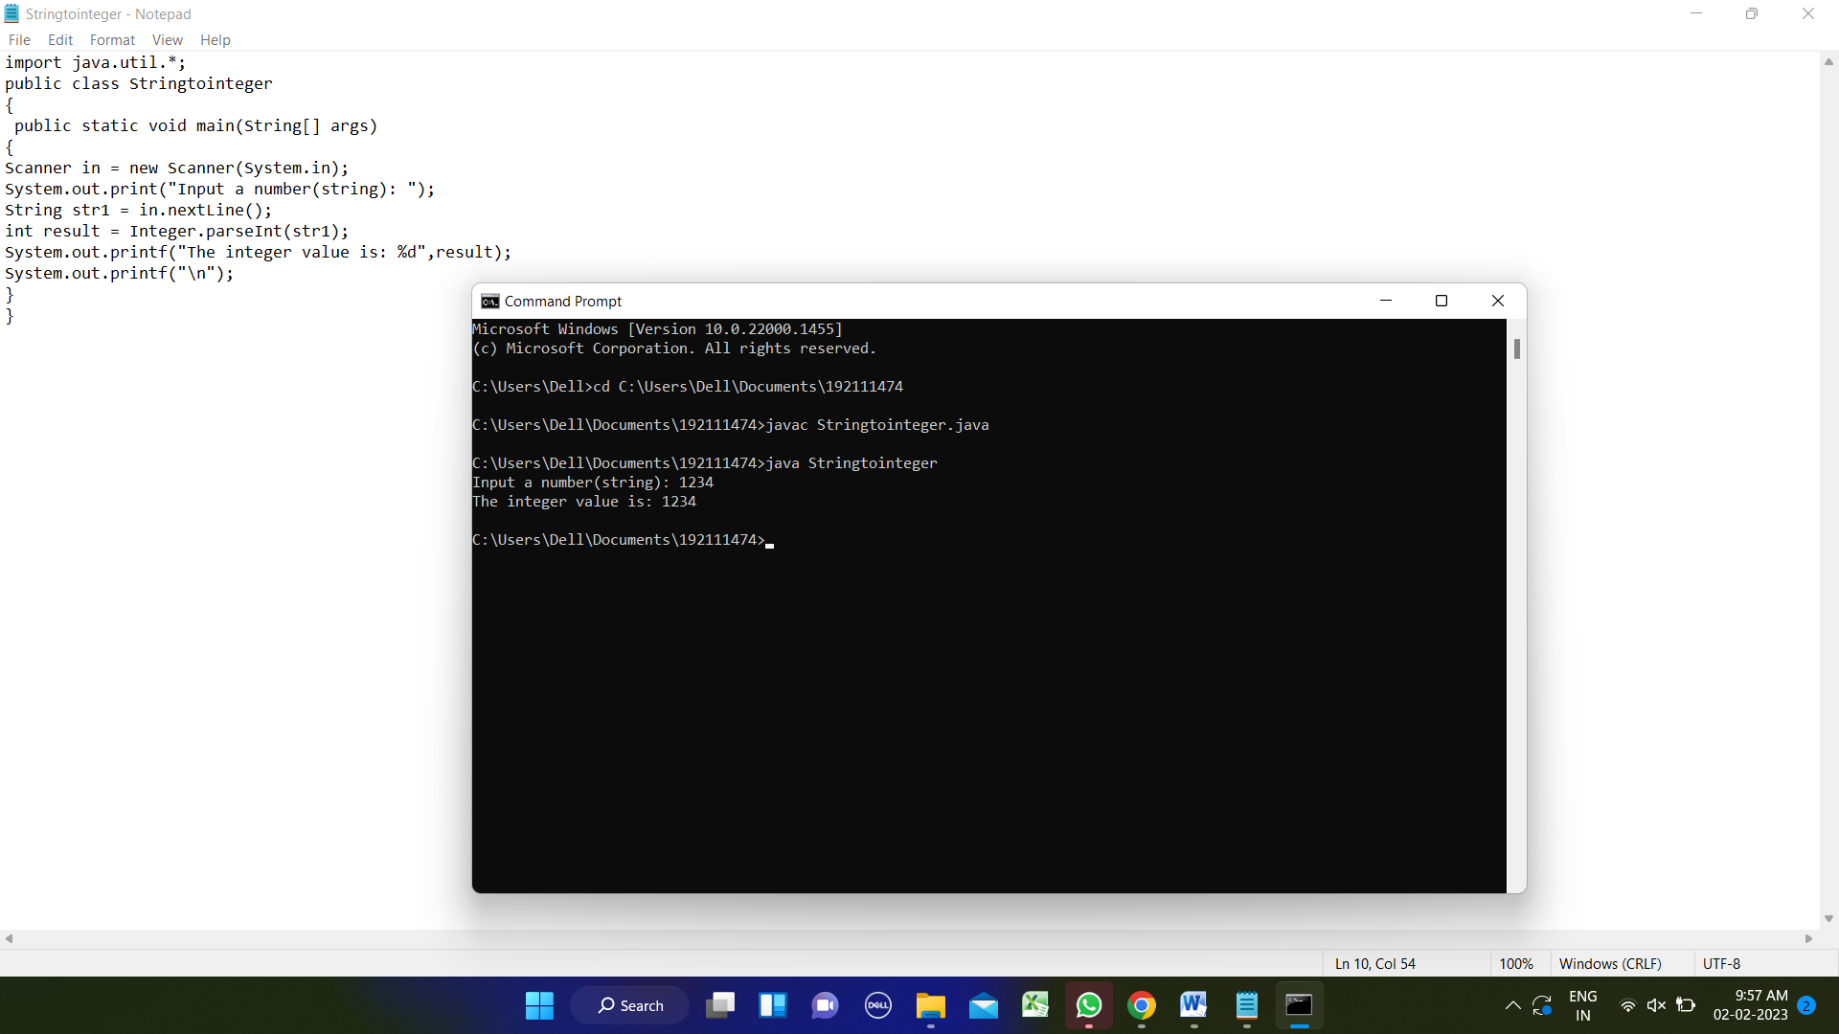

1. Write a program to check the entered user name is valid or not. Get both the inputs from the user.

import java.util.Scanner;

public class Solution

{

public static void main(String[] args){

Scanner sc = new Scanner(System.in);

String userName = sc.nextLine();

String regularExpression = "^[A-Za-z][A-Za-z0-9_]{7,29}$";

if (userName.matches(regularExpression)) {

System.out.println("Valid");

}

else

{

System.out.println("Invalid");

}

}

}

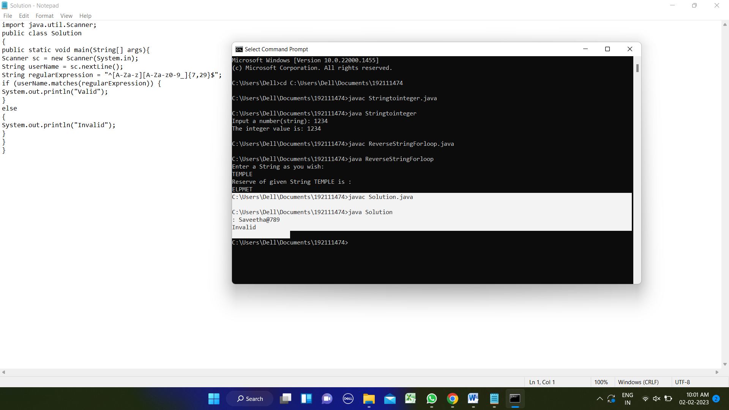

1. Write a program for matrix addition?

public class MatrixAddition

{

public static void main(String args[]){

int a[][]={{1,2},{5,3}};

int b[][]={{2,3},{4,1}};

int c[][]=new int[2][2];

for(int i=0;i<2;i++){

for(int j=0;j<2;j++){

c[i][j]=a[i][j]+b[i][j];

System.out.print(c[i][j]+" ");

}

System.out.println();

}

}

}

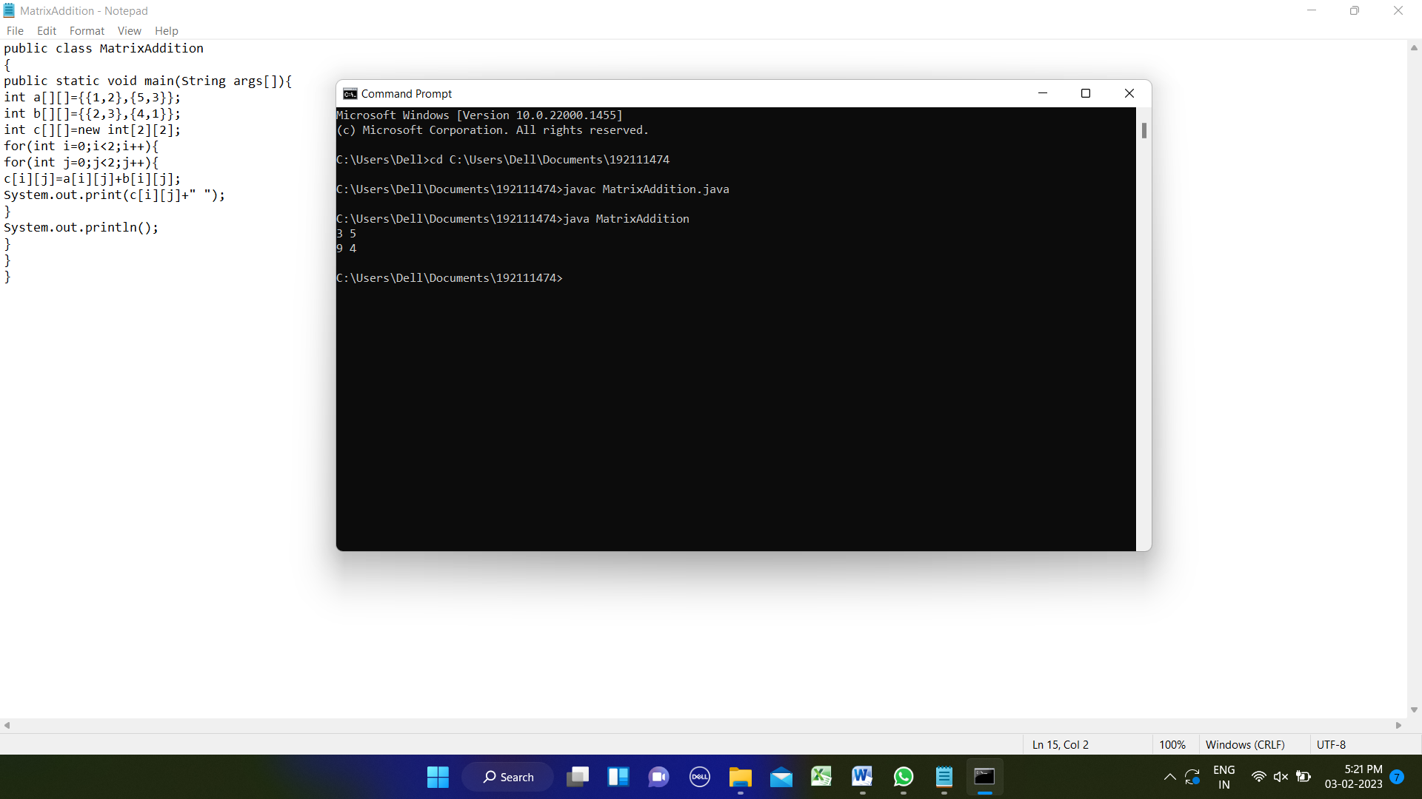

1. Write a program for matrix multiplication?

public class MatrixMultiplication

{

public static void main(String args[])

{

int a[][]={{1,2},{5,3}};

int b[][]={{2,3},{4,1}};

int c[][]=new int[2][2];

for(int i=0;i<2;i++)

{

for(int j=0;j<2;j++)

{

c[i][j]=0;

for(int k=0;k<2;k++)

{

c[i][j]+=a[i][k]*b[k][j];

}

System.out.print(c[i][j]+" ");

}

System.out.println(); }}}

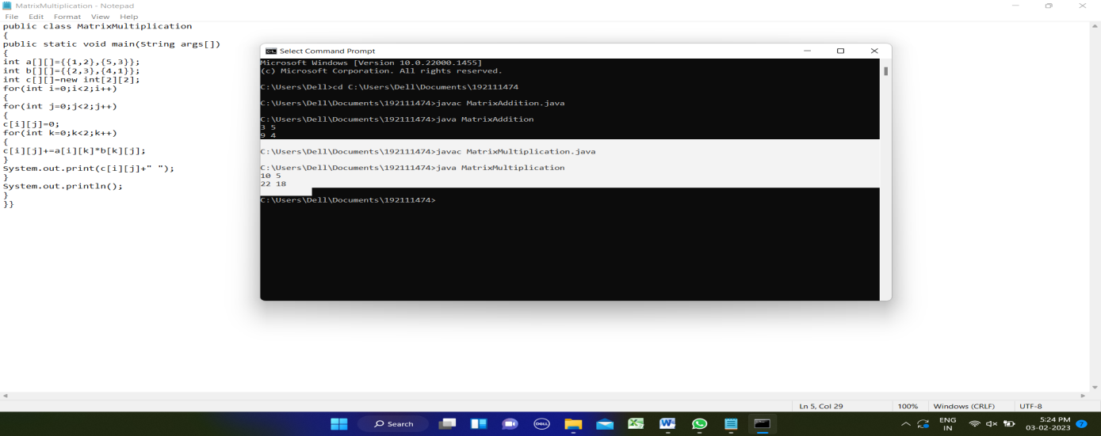

6.Write a program to convert the given decimal to binary and print the reverse of the binary

public class DecimalToBinary

{

public static void toBinary(int decimal)

{

int binary[] = new int[30];

int index = 0;

while(decimal > 0){

binary[index++] = decimal%2;

decimal = decimal/2;

}

for(int i = index-1;i >= 0;i--)

{

System.out.print(binary[i]);

}

System.out.println();//new line

}

public static void main(String args[])

{

System.out.println("Decimal of 11 is: ");

toBinary(11);

System.out.println("Decimal of 13 is: ");

toBinary(13); }}

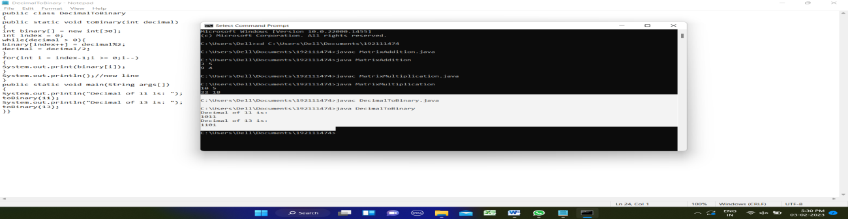

1. [Java Program to Find Even Sum of Fibonacci Series Till number N](https://www.geeksforgeeks.org/java-program-to-find-sum-of-fibonacci-series-numbers-of-first-n-even-indexes/)?

import java.util.Scanner;

public class FabonacciSum

{

public static void main(String[] args)

{

int my_input, i, sum;

System.out.println("Required packages have been imported");

Scanner my_scanner = new Scanner(System.in);

System.out.println("A reader object has been defined ");

System.out.println("Enter the value of N: ");

my_input = my_scanner.nextInt();

int fabonacci[] = new int[2 * my_input + 1];

fabonacci[0] = 0;

fabonacci[1] = 1;

sum = 0;

for (i = 2; i <= 2 * my_input; i++)

{

fabonacci[i] = fabonacci[i - 1] + fabonacci[i - 2];

if (i % 2 == 0)

sum += fabonacci[i];

}

System.out.printf("Even sum of fibonacci series till number %d is %d" , my_input, sum);

}

}

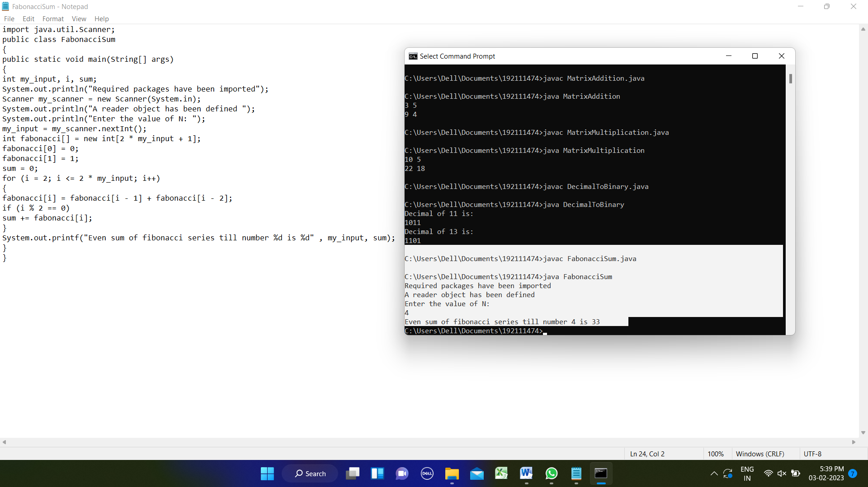

1. Program to find the frequency of each element in the array.

public class FrequencyElement

{

public static void main(String[] args)

{

int [] arr = new int [] {1, 2, 8, 3, 2, 2, 2, 5, 1};

int [] fr = new int [arr.length]; int visited = -1;

for(int i = 0; i < arr.length; i++)

{

int count = 1;

for(int j = i+1; j < arr.length; j++)

{

if(arr[i] == arr[j])

{

count++;

fr[j] = visited;

}

}

if(fr[i] != visited)

fr[i] = count;

}

System.out.println("---------------------------------------");

System.out.println(" Element | Frequency");

System.out.println("---------------------------------------");

for(int i = 0; i < fr.length; i++){

if(fr[i] != visited)

System.out.println(" " + arr[i] + " | " + fr[i]);

}

System.out.println("----------------------------------------");

}}

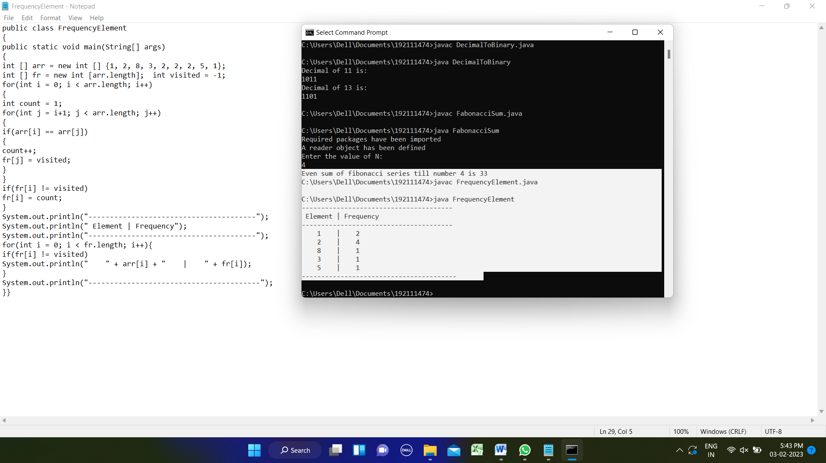

1. Write a program to find whether the person is eligible for vote or not. And if that particular person is not eligible, then print how many years are left to be eligible.

import java.util.*;

class Voting

{

public static void main(String args[])

{

Scanner sc = new Scanner(System.in);

System.out.println("Enter your age:\n");

int age=sc.nextInt();

if((age>=18)&&(age<=100))

{

System.out.println("Congratulation You are eligible for Voting");

}

else

{

System.out.println("Sorry You are not eligible for voting\n");

}

int a=18-age;

if (age<18&&age>0)

System.out.println("\n no.of years left to be eligible for vote "+a);

}

}

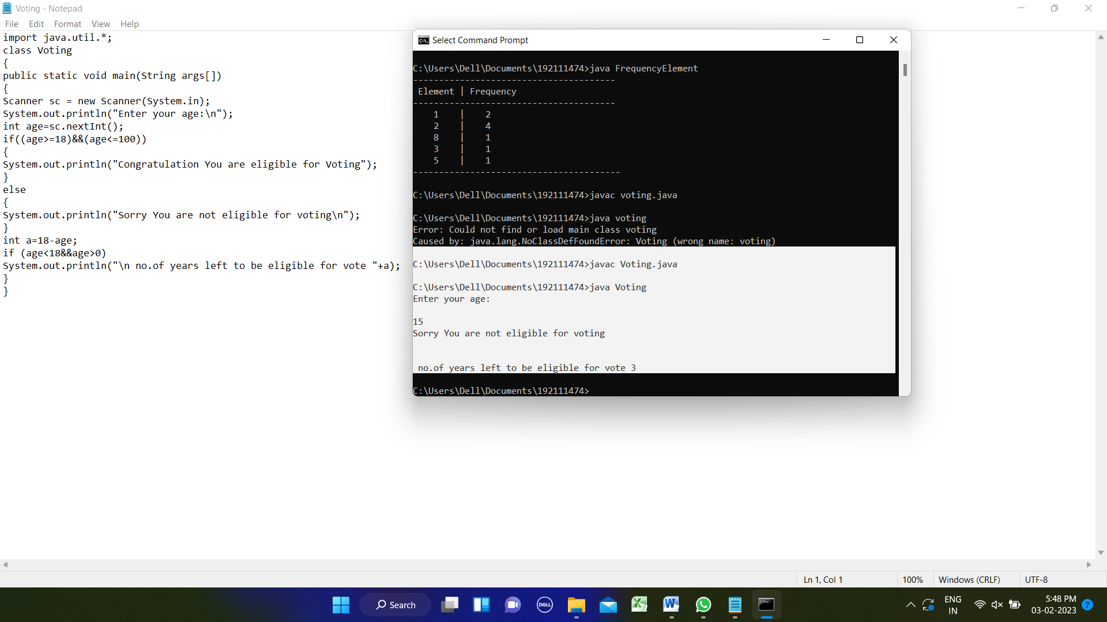

10. Write a program to print the below pattern

1

2 2

3 3 3

4 4 4 4

import java.io.*;

import java.util.Scanner;

class patternnum

{

public static void main(String args[])

{

for(int i=1;i<=4;i++)

{

for(int j=1;j<=i;j++)

{

System.out.print(i+" ");

}

System.out.println();

}

}}

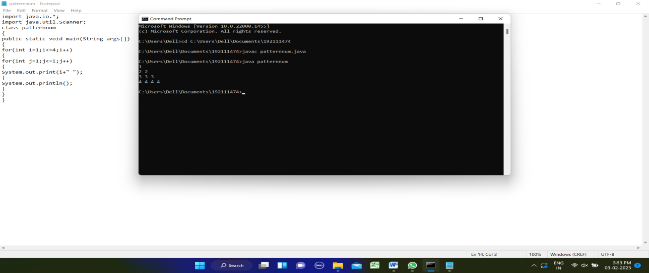

11.Write a program to print the given number is Perfect number or not?

import java.util.Scanner;

public class perfectnum

{

public static void main(String args[])

{

long n, sum=0;

Scanner sc=new Scanner(System.in);

System.out.print("Enter the number:");

n=sc.nextLong();

int i=1;

while(i <= n/2)

{

if(n % i == 0)

{

sum = sum + i;

}

i++;

}

if(sum==n)

{

System.out.println(n+" is a perfect number.");

}

else

System.out.println(n+" is not a perfect number.");

} }

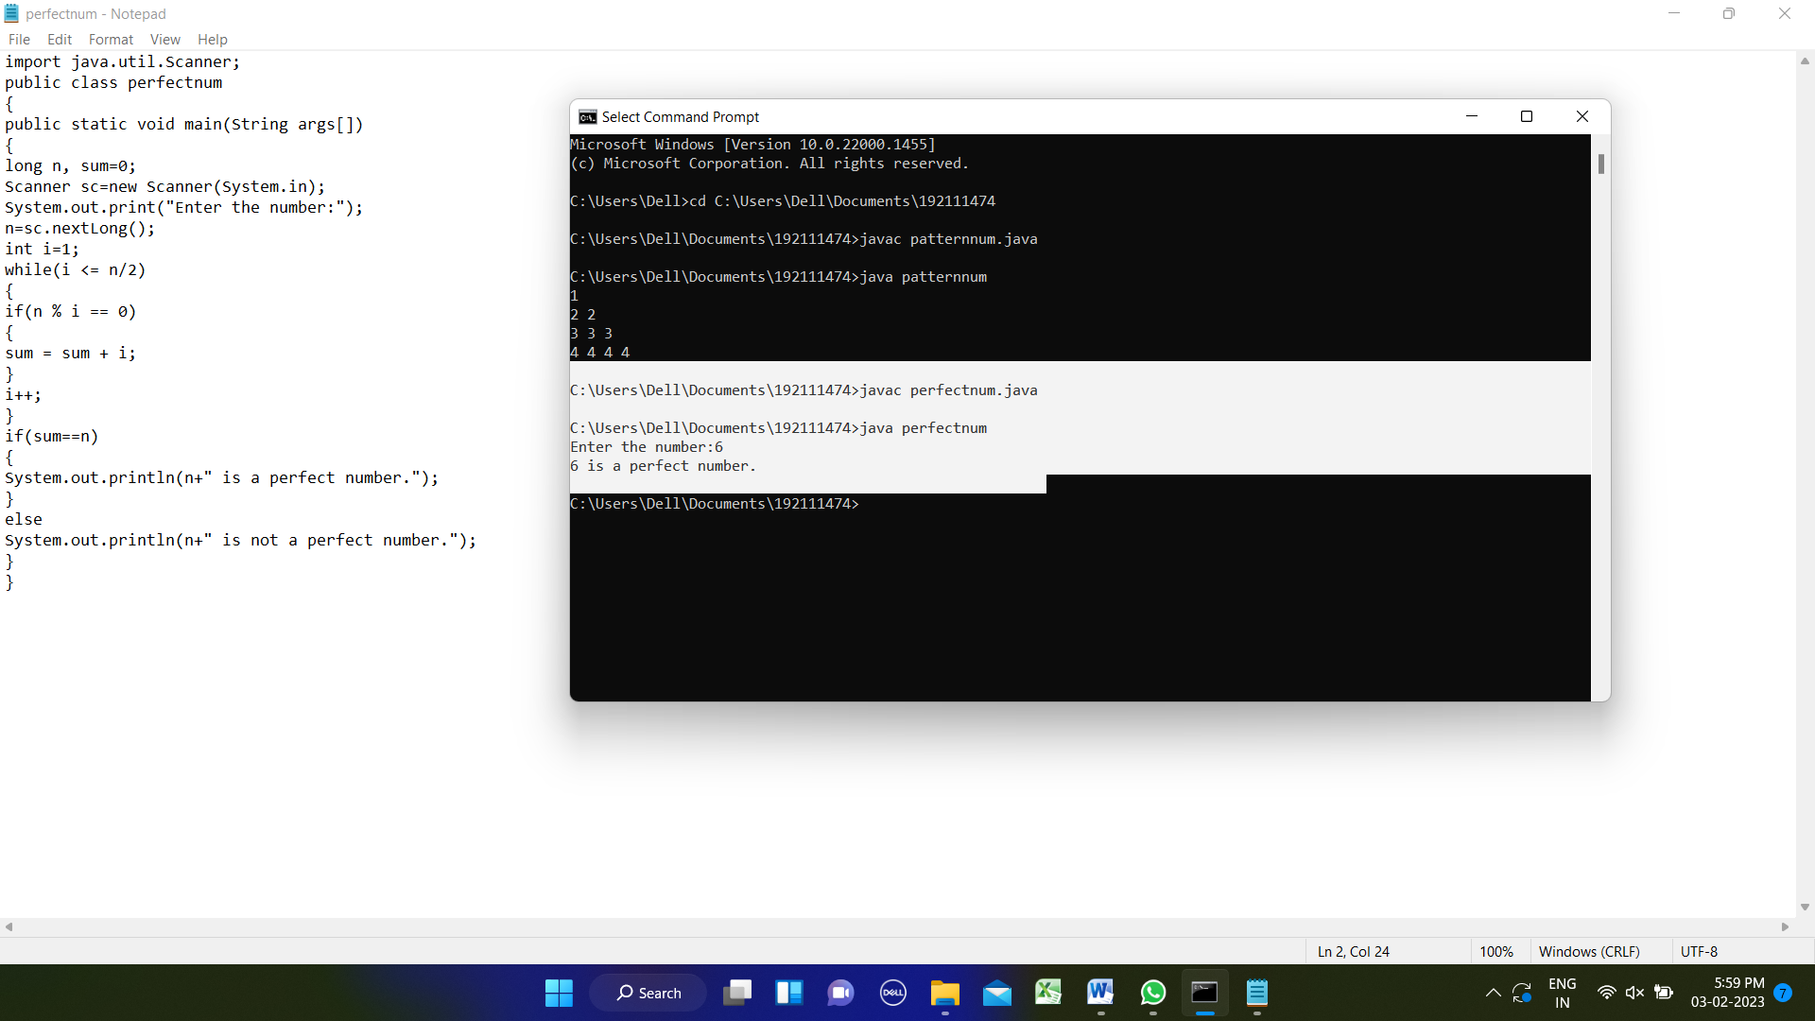

12. Write a program to print the special characters separately and print number of Special characters in the line?

import java.util.Scanner;

public class specialchar

{

public static void main(String[] args)

{

Scanner scanner = new Scanner(System.in);

System.out.println("Enter the string with special character = ");

String input = scanner.nextLine();

int counter = 0;

for (int i = 0; i < input.length(); i++)

{

if (isSpecialChar(input.charAt(i)))

{

counter++;

}

}

System.out.println("Count of special character = " + counter);

scanner.close();

}

public static boolean isSpecialChar(char ch)

{

boolean isSpecialChar;

if ((ch >= 'a' && ch <= 'z') || (ch >= 'A' && ch <= 'Z'))

{

isSpecialChar = false;

} else if (ch >= '0' && ch <= '9')

{

isSpecialChar = false;

} else

{

isSpecialChar = true;

}

return isSpecialChar;

} }

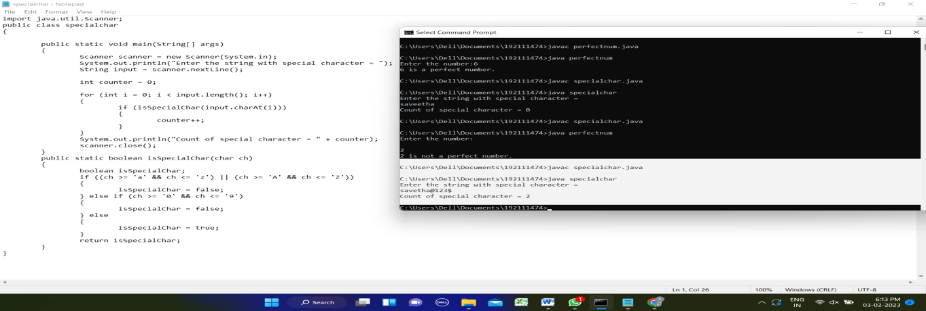

13. Find the factorial of n?

import java.util.*;

public class factorial

{

public static void main(String []args)

{

Scanner sc=new Scanner(System.in);

System.out.println("Enter the number: ");

int num=sc.nextInt();

int i=1,fact=1;

while(i<=num)

{

fact=fact*i;

i++;

}

System.out.println("Factorial of the number: "+fact);

}

}

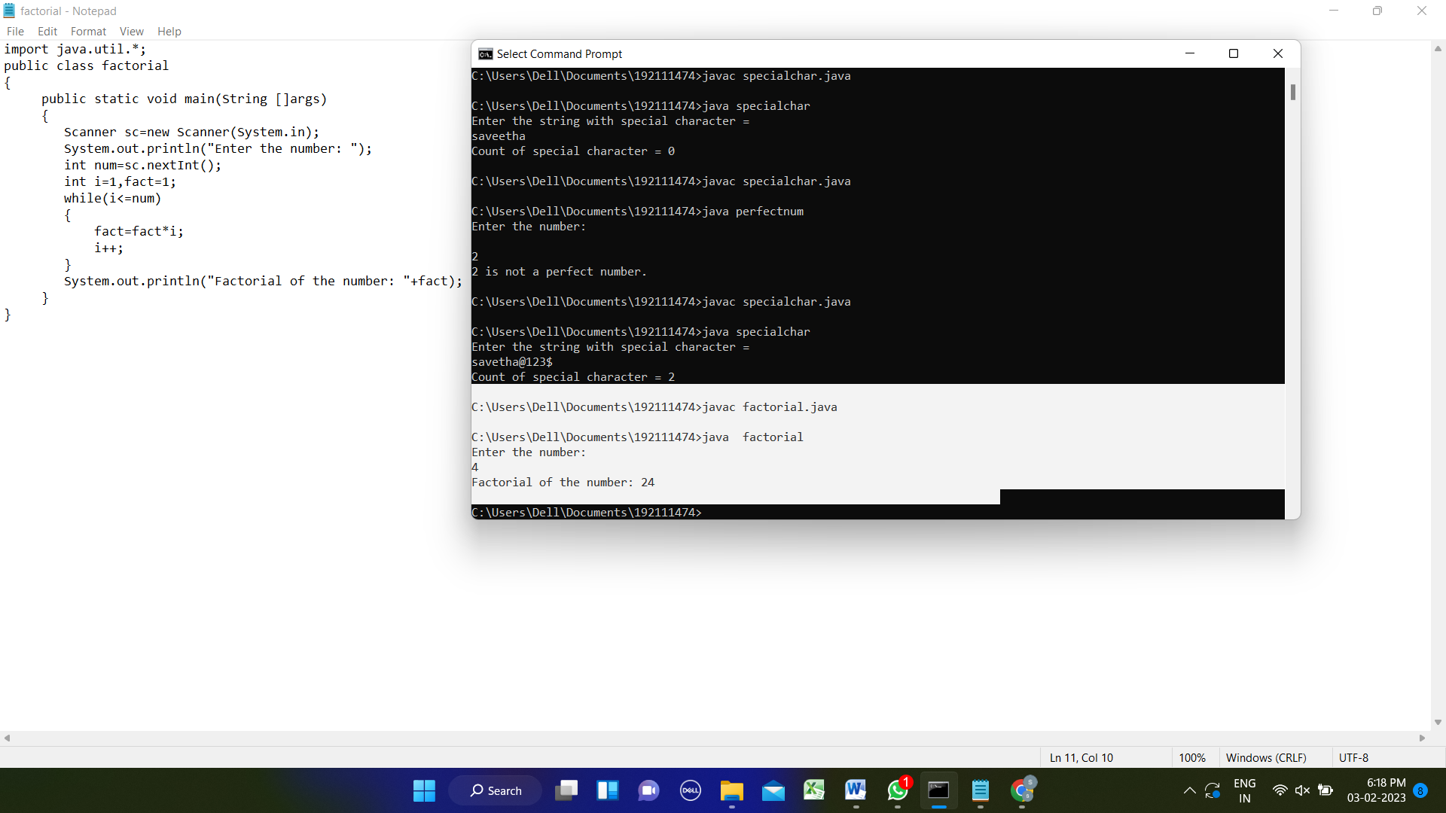

**14.** Write a program to print rectangle symbol pattern.

Get the symbol as input from user

import java.util.Scanner;

public class RectanglePattern

{

public static void main(String[] args) {

Scanner sc = new Scanner(System.in);

System.out.println("Enter row and col:");

int row = sc.nextInt();

int col = sc.nextInt();

System.out.print("Input a character: ");

char a = sc.next().charAt(0);

for (int i = 1; i <=row; i++) {

for (int j = 1; j <= col; j++)

if((i==1 || i==col) || (j==1 || j==col))

System.out.print(a);

else

System.out.print(" ");

System.out.println();

} } }

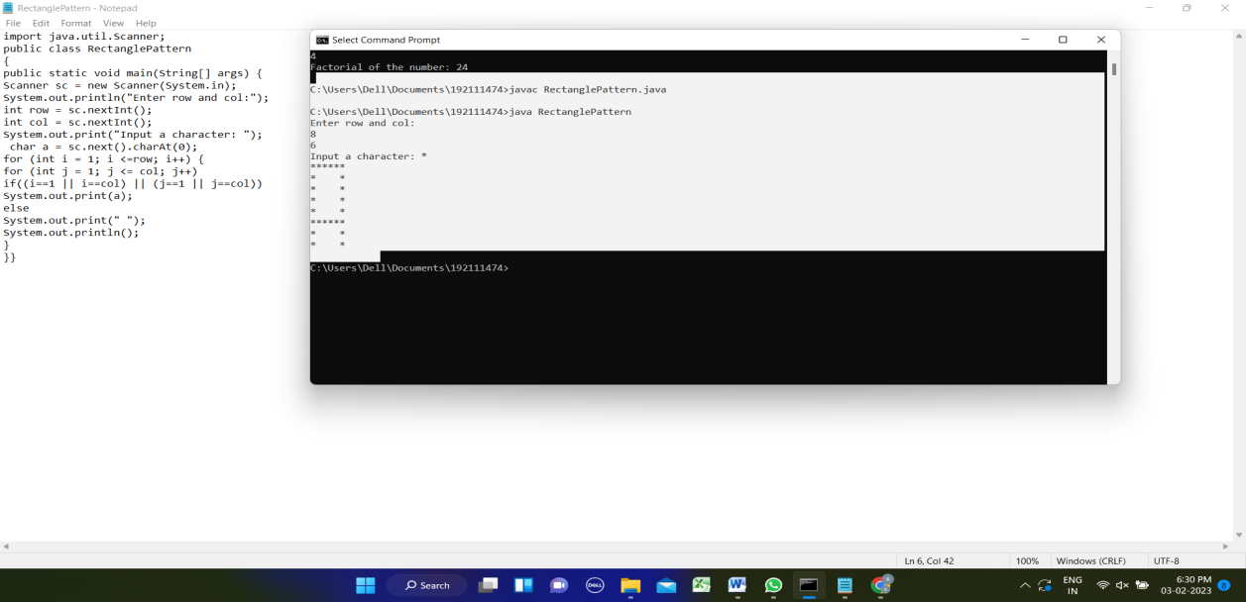

15. Write a program to print the following pattern ?

import java.util.Scanner;

public class Pattern

{

public static void main(String[] args)

{

Scanner sc = new Scanner(System.in);

System.out.println("How many rows you want in this pattern?");

int rows = sc.nextInt();

System.out.println("Here is your pattern....!!!");

for (int i = 1; i <= rows; i++)

{

for (int j = 1; j <= i; j++)

{

System.out.print("1");

}

System.out.println();

}

for (int i = rows-1; i >= 1; i--)

{

for (int j = 1; j <= i; j++)

{

System.out.print("1");

}

System.out.println();

}

sc.close();

}

}

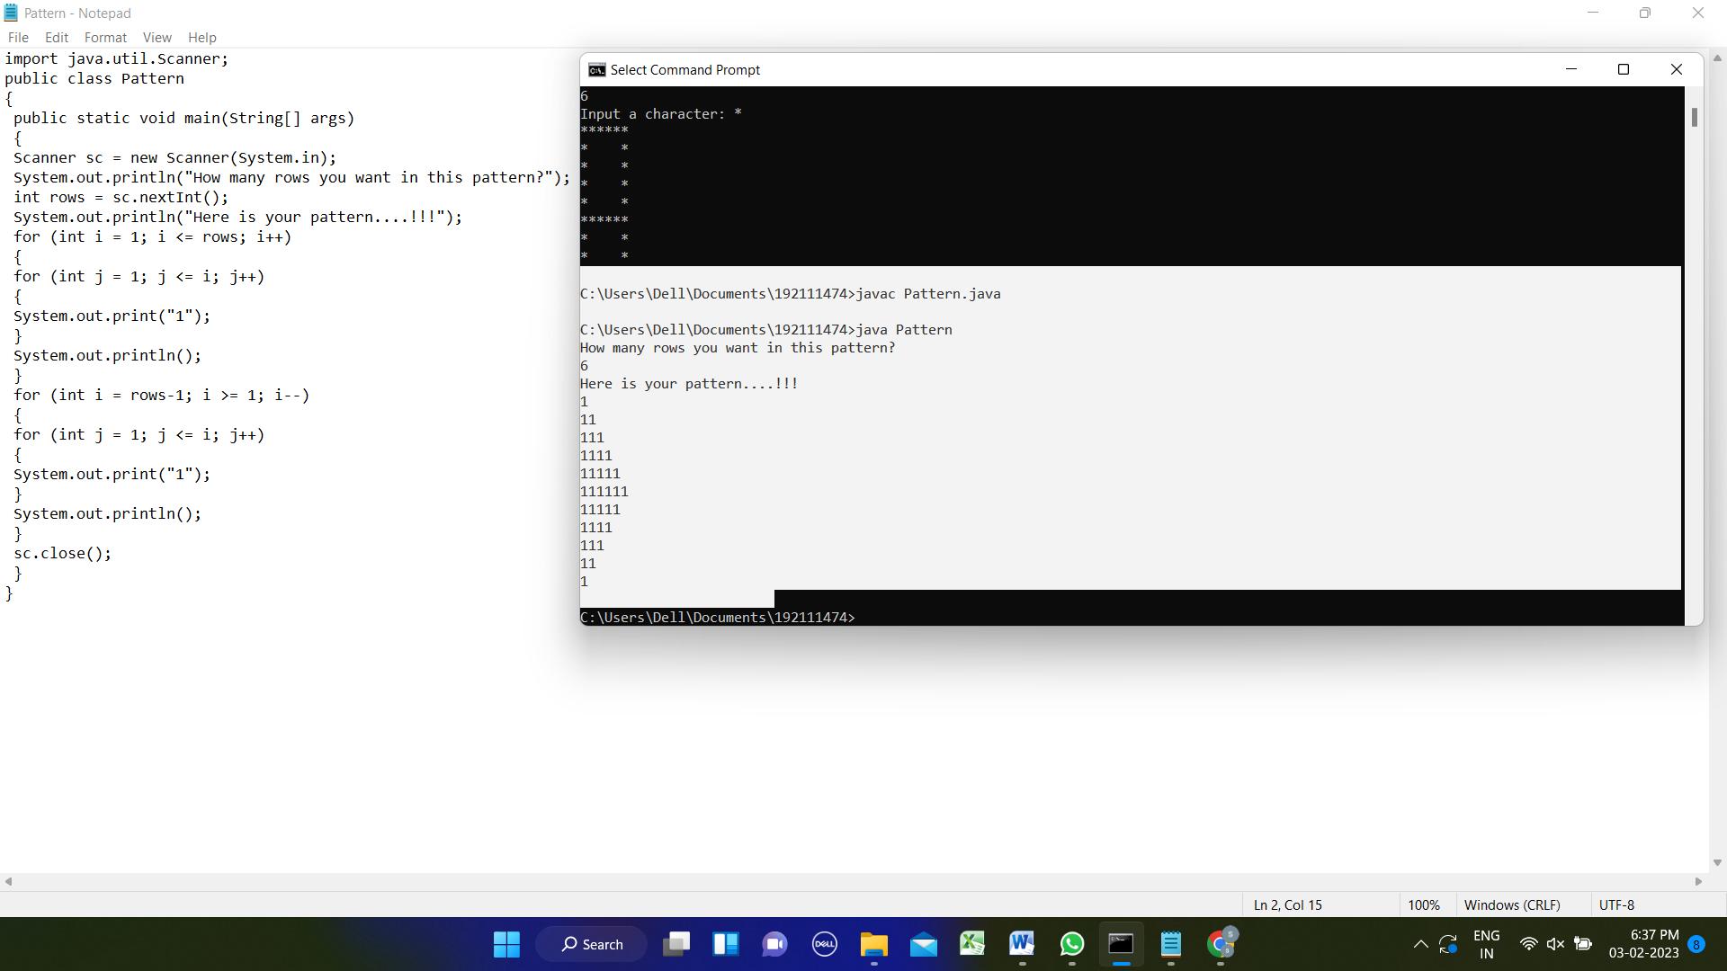

16. Write a program to print inverted pyramid pattern.

import java.util.Scanner;

public class invertedfullpyramid

{

public static void main(String[] args)

{

Scanner sc=new Scanner(System.in);

System.out.println("Enter N : ");

int n=sc.nextInt();

System.out.print("Enter Symbol : ");

char c = sc.next().charAt(0);

for(int i=n;i>0 ;i--)

{

for(int j=0;j<n-i;j++)

{

System.out.print(" ");

}

for(int j=0;j<(i*2)-1;j++)

{

System.out.print(c);

}

System.out.println();

}

} }

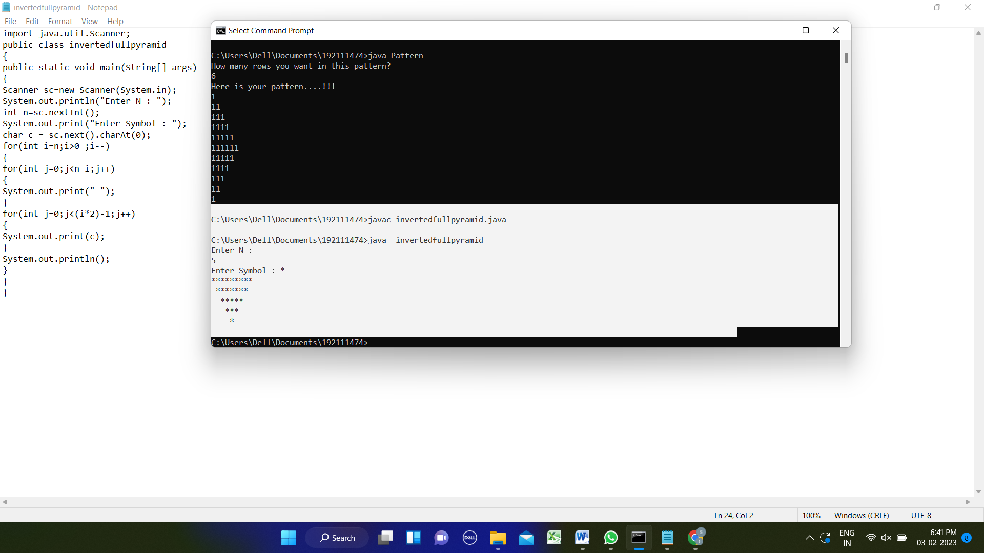

1. Write a program to print the hollow square pattern ?

import java.util.Scanner;

public class hollowsquare

{

public static void main(String[] args)

{

Scanner sc = new Scanner(System.in);

System.out.println("Enter row and col");

int row = sc.nextInt();

int col = sc.nextInt();

for (int i = 1; i <=row; i++)

{

for (int j = 1; j <= col; j++)

if((i==1 || i==col) || (j==1 || j==col))

System.out.print("*");

else

System.out.print(" ");

System.out.println();

}

}

}

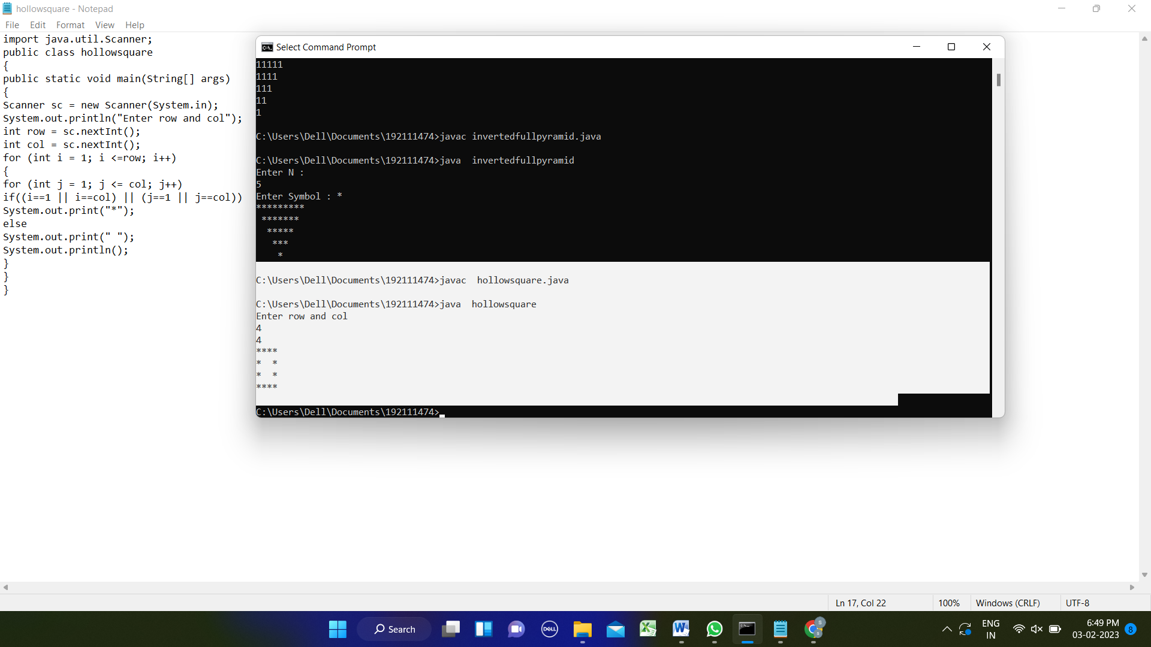

1. Write a program to reverse a number using loop?(Get the input from user)

import java.util.*;

public class reversenumber

{

public static void main(String[]args)

{

Scanner sc= new Scanner(System.in);

System.out.println("enter the number:");

String num =sc.nextLine();

System.out.println("reverse number is");

for(int i=num.length();i>0;--i)

{

System.out.print(num.charAt(i-1));

}

} }

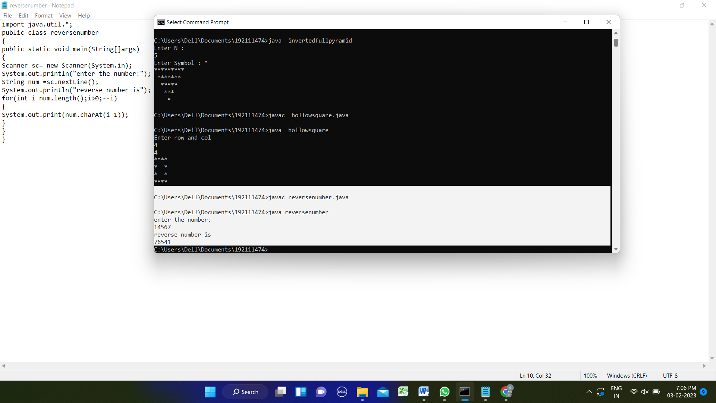

19. Write a program to print the below pattern

1

2 2

3 3 3

4 4 4 4

3 3 3

2 2

1

import java.util.*;

public class decimalpattern

{

public static void main(String[]args)

{

Scanner sc=new Scanner(System.in);

System.out.println("enter the no.of rows");

int n=sc.nextInt();

for(int i=1;i<n;i++)

{

for(int j=1;j<=i;j++)

{

System.out.print(i);

}

System.out.print("\n");

}

for(int i=n;i>=1;i--)

{

for(int j=1;j<=i;j++)

{

System.out.print(i);

}

System.out.print("\n"); } }

}

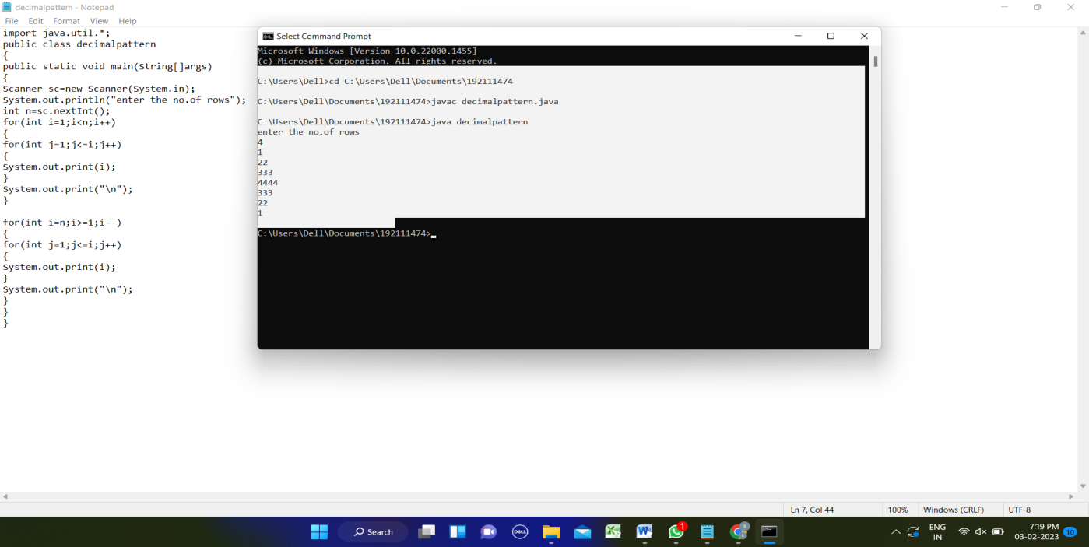

20. Write a program to find the square, cube of the given decimal number

import java.util.Scanner;

public class decimsqcb

{

public static void main(String args[])

{

Scanner input = new Scanner(System.in);

System.out.println("Enter the decimal number");

double num1 = input.nextDouble();

double squ = Math.pow(num1,(double) 2);

double cub = Math.pow(num1,(double) 3);

System.out.println("The square of the given decimal number is"+" "+squ);

System.out.println("The cube of the given decimal number is"+" "+cub);

}

}

